Characterization
“The Emperor’s New Clothes” Name: Period:
Directions: Write down a few character traits you would use to describe each of these characters. Then, under each trait, write a brief phrase or sentence explaining why.
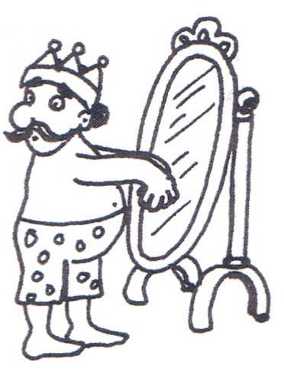
The Emperor
Trait: Why:
Trait: Why:
Trait: Why:
The Swindlers
Trait: Why:
Trait: Why:
Trait: Why:
The Emperor’s Men
Trait: Why:
Trait: Why:
Trait: Why:

