Name: Period:
Flowers for Algernon
- What are the advantages and disadvantages of popularity? Make a t-chart below. (At least 4)
- What are the advantages and disadvantages of intelligence? Make a t-chart below. (At least 4)
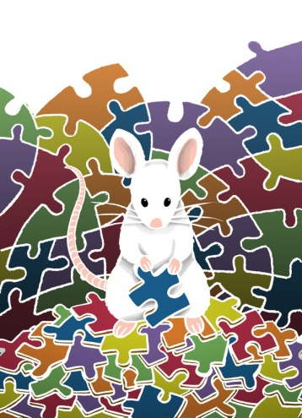
- What sacrifices do people make to fit in? Share an example from either personal experience or one you have witnessed.
- What is good or bad about being unusual? Explain in about 4-5 good sentences.

Name: Period:
Flowers for Algernon
Part I. Post Reading
- Reread your previous responses and think about the discussion we had before reading. Add a connecting thought below that may extend your thinking from before, or that may differ.
- In the bubble below, fill the left side with words and symbols that describe or suggest what Charlie is like before the operation, and on the right, with words and symbols that describe or suggest what he is like as he becomes more intelligent.
- On pg. 55, Charlie writes that he thinks “it’s a good thing about finding out how everyone laughs at” him. Do you agree? Why or why not? Be sure to explain in a few sentences and provide support for your position.
- Think about the last few lines in Part I. Why do people often dislike anyone who is different from them? What do you think of such attitudes? Be sure to explain in a few sentences and provide support for your position.
- Why do almost all of the workers in the factory sign the petition to have Charlie fired? Is their behavior believable? Explain.

Name: Period:
Flowers for Algernon
Part II. Post Reading
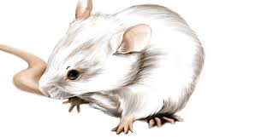
- What do you think becomes of Charlie after the story ends? Why?
- Why is Algernon important to Charlie?
- What does Charlie want most when we first meet him, after he becomes intelligent, and after his intelligence declines? Use the chart below to respond.
 | March 5- April 18 | April 20- June 15 | June 19- July 28
What Charlie wants

- In the April 9 entry in Part I (pg. 53), Charlie’s comments while reading Robinson Crusoe foreshadow, or hint at, how he will later find himself abandoned and alone. What other examples of foreshadowing do you find in the text? How did this make you feel?

- Would Charlies situation be better or worse if he had not had the operation? Support your opinion with evidence in the story.
- At the end of the story, Charlie writes, “Its easy to make frends if you let pepul laff at you.” Do you agree or disagree with this statement? Explain.
- Describe your feelings about “human engineering” – fore xample, using science to change a person’s intelligence or personality.

