The Monkey’s Paw Analysis
By: Erik Dwyer, Yahoo! Shine (2010)
"He wanted to show that fate ruled people's lives, and that those who interfered with it did so to their sorrow." In the short story, The Monkey's Paw, written by W. W. Jacobs, fate and chance play a major role. The story strongly suggests that a person's life is pre-determined by fate and interference would result in one's sorrow. An old, dirty paw belonging to a monkey acts as a talisman and therefore possesses strange powers. The author provides many hints that tempting fate by making three wishes to the monkey's paw is a grave mistake.
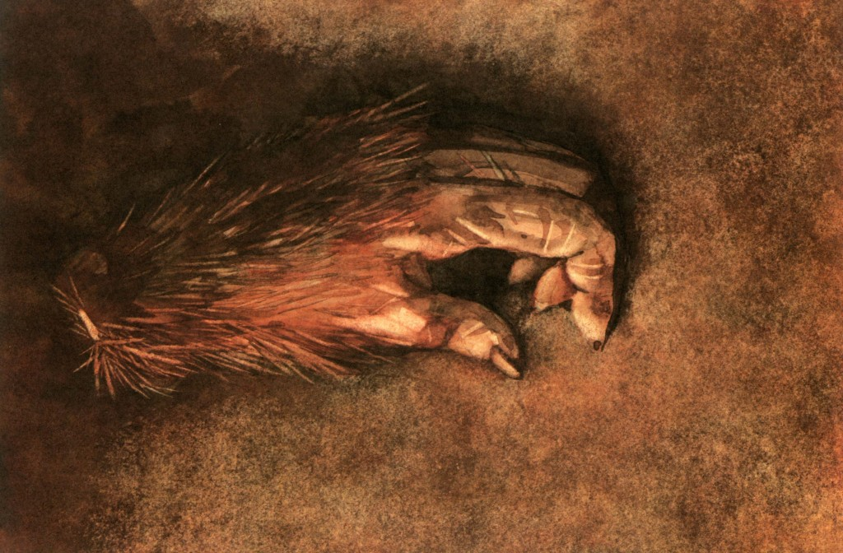
At the beginning of the story, it is interesting that the characters are playing chess, a game in which once a move is made, it cannot be undone. In the game of chess, what happens in the game is a result of the moves made by the player. Likewise, when making a wish via a talisman, a wish cannot be undone. "'The first man had his three wishes, yes,' was the reply. 'I don't know what the first two were, but the third was for death.'" The first user of the monkey's paw must have wished death in order to end the dire consequences of the first two wishes. Going back to the chess game, the author throws in the fact that the father, Mr. White, has made a fatal mistake which has resulted in the son's victory. The reader may not know it at first, but the chess game surely foreshadows events to come.
Fate plays a unique role as the story unravels. If one were to think about the story as a whole, it may seem that the characters were not interfering with fate at all, considering the earlier chess game. According to the chess game, Mr. White's fate was to try to interfere with fate. In other words, the chess game showed that his fatal move would directly affect his son. Mr. White's fatal move was to give in to the paw's wish granting temptation of getting whatever he wants by simply vocalizing a wish. Wishes are granted without a problem, but at a very high price.
Even though Mr. White's fate could have been to make a bad decision that affects his son, he could have altered his fate. When Morris threw the monkey's paw into the fire, in an attempt to dispose of it, Mr. White should have left it there to burn. The fire would have changed his fate of making a fatal mistake, but removed his chance of gaining three wishes. Mr. White was given a chance to save himself. The fire, at the beginning of the story was burning brightly; everyone was gathered around it, and it keeping everyone warm. This shows that the fire, while being a destructive force, was like the shining sun, keeping everything green and warm. Morris was trying to save Mr. White by throwing the paw in the fire. This action raises the question of why he had it in the White's house in the first place and why he did not dispose of it long ago.
After missing his chance to save himself and his family from sorrow, Mr. White decides to use the monkey's paw. Unsure of what to wish for, "Mr. White took the paw from his pocket and eyed it dubiously. 'I don't know what to wish for, and that's a fact,' he said slowly. 'It seems to me I've got all I want.'" Even though Mr. White stated that he had nothing to wish for, the monkey's paw glimmered with temptation and the ability to grant wishes and alter his life. What is interesting is that Herbert, Mr. White's son, is the one to suggest the wish of acquiring twohundred pounds. This is interesting because he ends up paying the unusual and unexpected price of the wish being fulfilled.
The monkey's paw keeps its promise of bringing two hundred pounds into Mr. White's life but as cautioned, at a cost. The two hundred pounds is produced as compensation for Herbert's fatal work accident. What the fakir in India who cursed the monkey's paw said is exactly what happened. Wishes are granted at a great cost.
After losing their son and gaining two hundred pounds, the Whites later decide to make another wish. The wish is to bring the son back. What I cannot figure out, due to the abrupt ending of the story, is what the third wish was. It seems "obvious" that the third wish, after wishing for the son back, was to make the son go away again. Since the third wish is not revealed, it could be something else. Who was knocking at the door? Was it the son or was it someone else? The story seems to say that the person at the door was Herbert back from the dead. Mr. White then wishes for the son to go away and for the second wish to be cancelled because he realizes that his son is very mutilated. Couldn't the third wish be for the son to be back to normal appearance? The short story The Monkey's Paw is an interesting tale of fate and chance. The temptation brought on by the paw's three wishes of interfering with fate has its lessons. Fate has always been a major element in literature and continues in this short story. People always wish for things in their life although wishes usually never come true. The truth is that one must be careful what one wishes for because when the wish comes true, it may bring regret and sorrow. Using the monkey's paw to fulfill three wishes is tempting fate and is a grave mistake.
“He was caught in the machinery,” said the visitor at length in a low voice.
“Caught in the machinery,” repeated Mr. White, in a dazed fashion, “yes.”
Herbert White’s death has a literal meaning and two metaphorical meanings. Literally, Herbert died because he became entangled in the machinery, his body so mangled that Mr. White was able to identify his son only by examining his clothes. Metaphorically, however, Herbert died because after being caught in the machinery of fate, which went awry after Mr. White tampered with fate by making his wish for more money. A subtler metaphorical meaning has to do with Herbert’s employer. An undercurrent of class consciousness runs through “The Monkey’s Paw,” a story that concerns the fate of three lower-middle-class people. It is possible to read the Whites’ dire fate not as something they brought upon themselves through greediness, but instead as the unfair effect of a modest wish made by a family struggling with debts and a small income. Jacobs suggests that anyone, even the most moral reader, would behave exactly as the Whites did, making a small, practical wish just to see what might happen.
Jacobs uses Herbert’s death to suggest that society is unfair to the good, hardworking people in the lower classes. Evidence of this worldview comes in the form of the Maw and Meggins representative, who shamefacedly announces that his company will decline to take any responsibility for the accident, but will effectively offer Mr. and Mrs. White a bribe to keep quiet. The first word of the company name, maw, means voracious, gaping mouth. The suggestion is that Herbert has been swallowed whole by a cruel world, and all because of one understandable wish made by a man who simply wants to own his own house.

