Name: Period:
“The Monkey’s Paw”
Making Predictions: What’s Next?
The Monkey’s Paw is a masterpiece of suspense that keeps the reader guessing—and dreading—what will happen next. Try playing a guessing game with the play as you read. Look at the symbols next to the questions on the right. When you come across a symbol in the play, turn back to this page and find the question appearing next to the same symbol. Respond briefly to the question in your notebook. Then, continue reading to see if events turn out as you predicted.
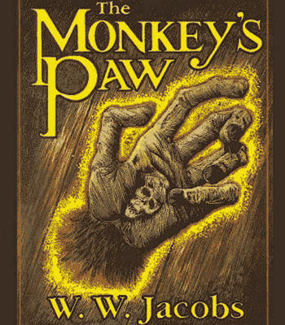
Look at the title and the illustration on page 186. What do you think this story will be about? What role will the monkey’s paw play?
What do you think the consequences of Mr. White’s wish will be?
Before you start reading Scene 3, jot down your thoughts on what the Whites will do next. What would you do?
What do you think will be the result of the second wish?
What was the third wish? Did you predict it?

